High Level Design Specification
FOR
Volunteer Management System
(VMS)

CLIENT | Liu Peishan
PROJECT | Volunteer Management System (VMS)
TITLE | High Level Design Specification
VERSION | 1.0
DATE | 06-Aug-2011
 | ORIGINATOR
 | Name / Signature | Team 8S
 | APPROVAL
 | Name / Signature | Phung Kim Cuong, Dio
Institute of Systems Science |  | Document Reference
25 Heng Mui Keng Terrence  Singapore 119615 |  | VMS/T-1.5.1/1

 | Acceptance
 | Customer Signature |  | Customer Signature
 | Name & Designation |  | Name & Designation
 | Date & Company Stamp |  | Date & Company Stamp

Revision History

Date | Version | Description | Author
06-Aug-2011 | 1.0 | Creation | Team 8S

Table of Contents

1. Document Overview 4
1.1 Target Audience 4
2. High Level Application Architecture 5
2.1 Application Architecture Overview 5
2.2 Hardware Architecture 5
3. Technologies & Tools 6
3.1 Client 6
3.2 Web Layer 6
3.3 Middle Tier 7
3.4 Data Layer 7
4. Project Development Structure 7
4.1 Development Structure 7
4.2 Development Tools 8
4.3 Development Environment 9
5. User Interface Design Guidelines 9
5.1 JSTL 9
5.1.1 JSTL Core Library 9
5.1.2 Formatting Library 10
5.1.3 Function Tag Library 10
5.2 DWR(Direct Web Remoting) 11
5.2.1 Configuration 11
5.3 Dynamic Interactions 12
Request-Response Flow 12
5.3.1 12
AOP Authentication and Authorization 12
5.3.2 12
5.3.2.1 Configuration 12
Form Validation 13
5.3.3 13
5.3.3.1 Configuration 13
Sample Configuration: 14
Sample Configuration: 14
6. Middle Tier (Spring) 14
6.1 Static Structure 14
6.2 Dynamic Interactions 15
6.3 Configuration 16
7. Persistence 16
7.1 Static Structure 17
7.2 Dynamic Interactions 17
7.3 Configuration 19
7.4 Standards 20
8. Reporting Utility 20
8.1 Static Structure 20
8.2 Dynamic Interactions 21
9. Others 21
9.1 Build Configuration 21
9.2 Other Configurations 21
9.2.1 Configuration 22
9.2.2 Database Configuration 22
9.2.3 Logger Configuration 22
9.3 Java Naming Convention 22
9.3.1 Package 22
9.3.2 Class and Interface 23
9.3.3 Method 23
9.3.4 Attribute and Local Variable 23
9.3.5 Class & UI Naming Convention 24
9.3.6 Documentation 24
9.3.6.1 Acceptable 24
9.3.6.2 Unacceptable (no Javadoc tag) 25
ANNEX D Amendment History 26

Document Overview
This document describes the high level design architecture for the VMS application’s components and development patterns adopted. VMS system (hereby refer to as system) is used by the NGO staff and volunteers and is designed as a public web based application.

Target Audience
The intended readers of this document are:
- the development team, to provide them with a high level design of the system and high level standards and guidelines for the development of the system.
- Design team, to provide them an overview of system design and also to provide a start for design work

High Level Application Architecture

Application Architecture Overview
The following depicts the requirements functionalities that reside in the system.
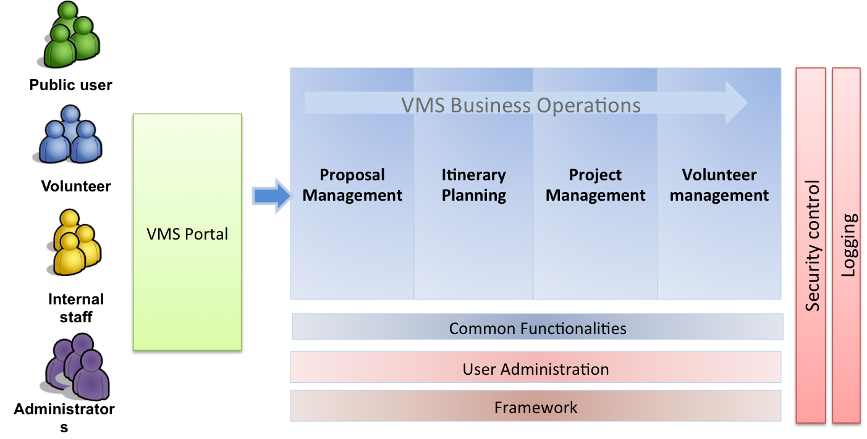

Figure 1 – Application Architecture Diagram

Hardware Architecture
The following depicts the hardware architecture design of the system. The system will be running on a Windows platform.
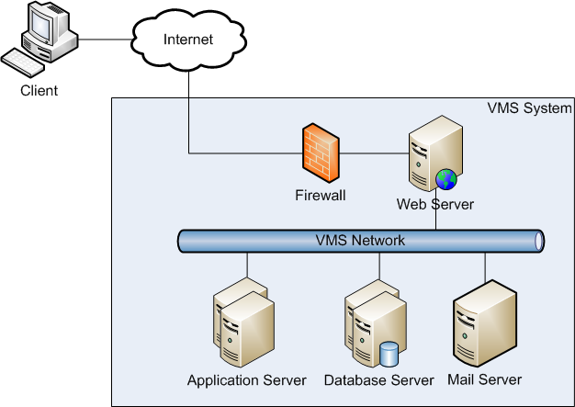

Figure 2 – Hardware Architecture

All clients will submit requests through the Internet browser. All requests will go through the firewall before entering into the internal network of the VMS. The web server will handle the requests and then be submitted to the application servers, which will then interact with the database servers or mail server for data manipulation and sending of emails.

Technologies & Tools
The following diagram depicts the technologies and tools used for this system.
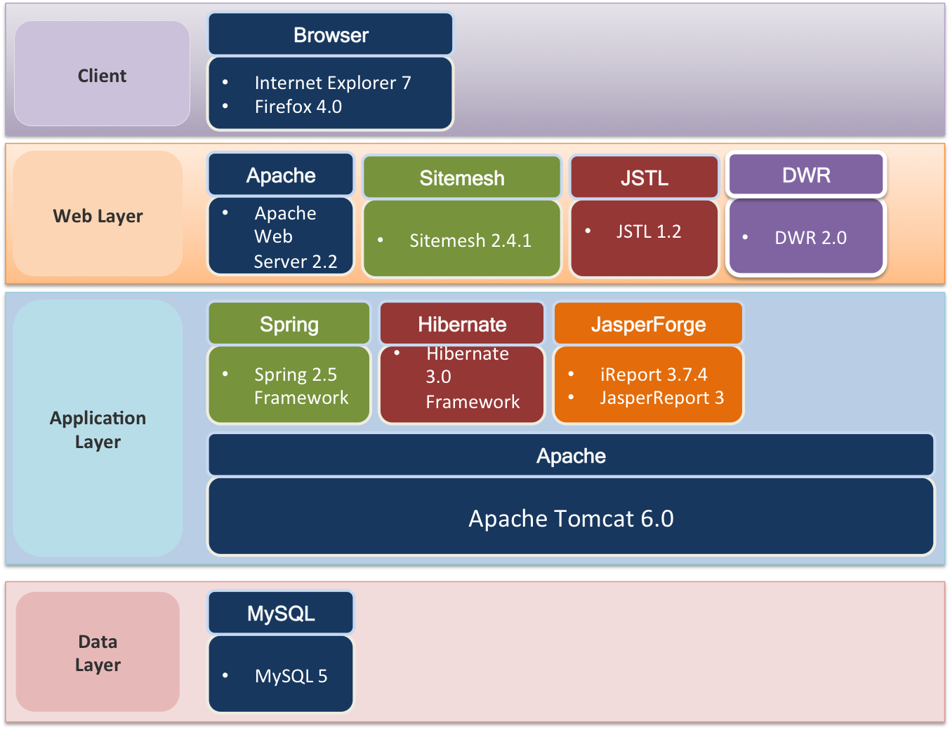

Figure 3 – Overview of Technologies & Tools

Client
The system will support the Internet Explorer 7 and Firefox 4.

Web Layer
The front-end web tier layer will be handling the request submission by the users. The Sitemesh will be used for decide for the layout of web page. JSTL tag libraries are used to defining the presentation tier items such as the use of messages to define labels. DWR is used to interact with java functions running on a server with the browser.

Middle Tier
The middle tier, which is also known as the application layer, consists of the components used to implement the application. The application will be hosted on the Apache Tomcat version 6 servers.
The application will be created using the Spring 2.5 MVC framework, Hibernate 3 and JasperReport 2.0.5 to form up the core component of the whole application. The Spring framework consists of the web controller which will receive requests from the web layer. Hibernate is used as for persisting and retrieval of data. A business façades layer will also be created to interface with the web controller as well as the Hibernate framework. This will hide the core business logic away from the web layer, which is focused on rendering the user interface.

Data Layer
The data layer consists of the database component. The database of choice is MySQL 5. This database will be storing and handling all the records of the system.

Project Development Structure

Development Structure
The development package should have a parent package of
sg.edu.nus.iss.vms.<module>
Modules are based on common items and of use cases. Each is further broken down into dto, dao, controller and service packages. The dto package will contain the entity objects. The dao package will store the data access objects. The controller keeps the spring controller objects for the web requests and finally the service package defines the core business logics of the application.
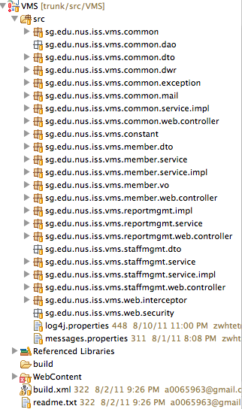

Figure 4 – Development Structure

Development Tools
The tools that will be used for development includes the following:
- Eclipse 3.5
- JDK 6
- Tomcat 6
- Ant 1.6.5
- iReport 3.7.4

Development Environment
Each developer machine will need to install an eclipse with a local tomcat installed. Developer will connect to a central development database.

User Interface Design Guidelines

JSTL
The JSP Standard Tag Library (JSTL) is a collection of JSP 1.2 custom tag libraries that implement basic functionality common to a wide range of server-side Java applications. By providing standard implementations for typical presentation-layer tasks such as data formatting and iterative or conditional content, JSTL allows JSP authors to focus on application-specific development needs, rather than "reinventing the wheel" for these generic operations.
The following JSTL libraries will be used to simplify JSP development.
Library | URI | Prefix
Core  Bean access, flow control, collection handling, URL management | http://java.sun.com/jsp/jstl/core | c
Formatting  I18N formatting for messages, numbers and dates | http://java.sun.com/jsp/jstl/fmt | fmt
Functions  String manipulation | http://java.sun.com/jsp/jstl/functions | fn
Table 1 – System Deliverables

JSTL Core Library
Displaying Value
<c:out> :
evaluate an expression and output the result of the evaluation to the current
JspWriter object.
<c:set>:
Sets the value of a scoped variable or a property of a target object.
Conditional Action
<c:if>:
Evaluates its body content if the expression specified with the test attribute is true.
<c:choose>
Provides the context for mutually exclusive conditional execution.
Iterator Action
<c:forEach>
Repeats its nested body content over a collection of objects, or repeats it a fixed number of times.

URL Related Action
<c:url>
Builds a URL with the proper rewriting rules applied.
<c:redirect>
Sends an HTTP redirect to the client.
<c:param>
Adds request parameters to a URL. Nested action of <c:import>, <c:url>,
<c:redirect>.
Sends an HTTP redirect to the client

Formatting Library
Formatting Numbers, Currencies, and Percentages
<fmt:formatNumber>
Formats a numeric value in a locale-sensitive or customized manner as a number
Formatting Dates and Times
<fmt:parseDate>
Parses the string representation of dates and times that were formatted in a localesensitive
or customized manner.

Function Tag Library
fn:toLowerCase, fn:toUpperCase
Change the capitalization of a string
fn: substring, fn: substringAfter, fn: substringBefore
Get a subset of a string
fn: trim
Trim a string
fn: replace
Replace characters in a string
Fn: indexOf, fn: startsWith, fn:endsWith, fn:contains
Check if a string contains another string

DWR(Direct Web Remoting)
DWR is open source java library, which allows code in a web browser to use java functions running on a web server as if it was in the browser. DWR consists of two main parts: Java Serlet and JavaScript. It dynamically generates JavaScript code based on Java classes.

Configuration
1. Add the sevlet-mapping in web.xml
<servlet-mapping>
<servlet-name>springDispatcher</servlet-name>
<url-pattern>/dwr/*</url-pattern>
</servlet-mapping>

2. Configure namespace
The following lines (in bold, below) need to be added to any of Spring XML files that includes at least one DWR specific tag. Add them inside the beans declaration (at the beginning of the file):
<beans
xmlns="http://www.springframework.org/schema/beans"
xmlns:xsi="http://www.w3.org/2001/XMLSchema-instance"
xmlns:dwr="http://www.directwebremoting.org/schema/spring-dwr"
xsi:schemaLocation="http://www.springframework.org/schema/beans
http://www.springframework.org/schema/beans/spring-beans-2.5.xsd
http://www.directwebremoting.org/schema/spring-dwr
http://www.directwebremoting.org/schema/spring-dwr-3.0.xsd">

3. Configure remote tag
Inside each bean to remote we will include a <dwr:remote javascript="Fred"> tag. There the methods that are going to be proxied and those that won't can be specified . For example:
<bean id="timeConvert" class="sg.nus.iss.vms.ui.util.ConvertCalendar">
<dwr:remote javascript="CalendarConvert">
<dwr:include method="convert" />
</dwr:remote>
</bean>

Dynamic Interactions

Request-Response Flow
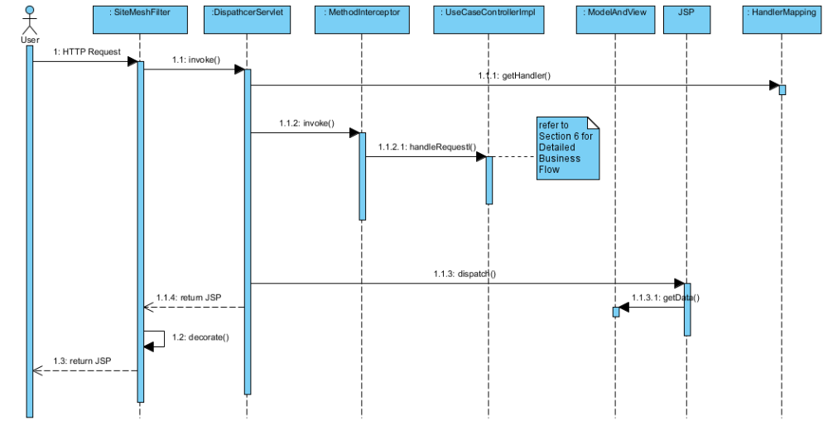
Figure 5 – Request-Response Flow

AOP Authentication and Authorization
Spring Security provides comprehensive security services for J2EE-based enterprise software applications. There is a particular emphasis on supporting projects built using The Spring Framework. Authentication and authorization are the two main areas that Spring Security targets.

Configuration
- Add a DelegatingFilterProxy in the web.xml

<filter>
<filter-name>springSecurityFilterChain</filter-name>
<filter-class>org.springframework.web.filter.DelegatingFilterProxy</filter-class>
</filter>

<filter-mapping>
<filter-name>springSecurityFilterChain</filter-name>
<url-pattern>/*</url-pattern>
</filter-mapping>

<context-param>
<param-name>contextConfigLocation</param-name>
<param-value>/WEB-INF/spring-mvc-security.xml</param-value>
</context-param>
2. Declare a custom XML config named spring-security.xml that contains configuration related to Spring Security.

<security:http auto-config="true" use-expressions="true" >

<security:intercept-url pattern="/login" access="permitAll"/>
<security:intercept-url pattern="/staff" access="ROLE_STAFF”/>
<security:intercept-url pattern="/user" access="ROLE_USER"/>

<security:form-login
login-page="/login"
authentication-failure-url="/login?error=true"
default-target-url="/user"/>

</security:http>

Dynamic Interaction

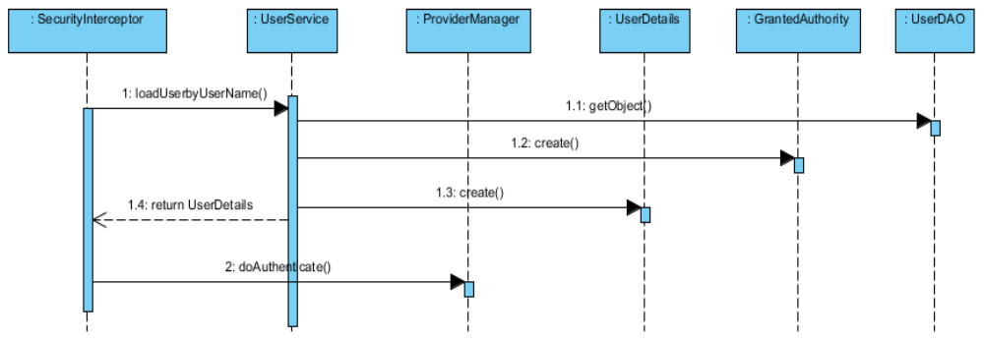
Figure 6 – Authentication & Authorisation

Form Validation
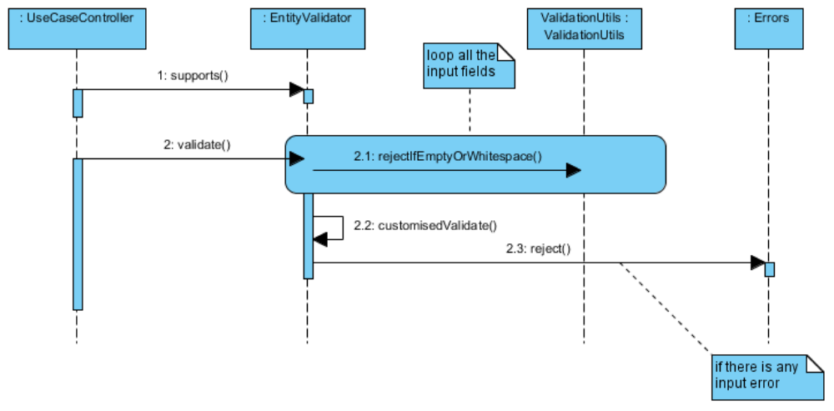
Figure 7 – Form Validation

Configuration
- add the form:errors tags in the jsp page to display the errors.

Sample Configuration:
<form:form method="POST" commandname="user">
<table>
<tr>
<td>User Name :</td>
<td><form:input path="name" /></td>
<td><form:errors path="name" cssClass="error" /></td>
</tr>
<tr>
<td>Password :</td>
<td><form:password path="password" /></td>
<td><form:errors path="password" cssClass="error" /></td>
</tr>
</table>
</form:form>
- In the Spring configuration file, link the Validator with the Controller using the validator-ref property and add the properties file.

Sample Configuration:
<bean id="userValidator" class=" sg.edu.nus.iss.vms.web.validator.UserValidator" />
<bean name="/userRegistration.htm" class=" sg.edu.nus.iss.vms.web.controller.UserController" p:userService-ref="userService" p:formView="userForm" p:successView="userSuccess" p:validator-ref="userValidator" />

Middle Tier (Spring)

Static Structure
The following class diagram illustrates the static structure of the design.
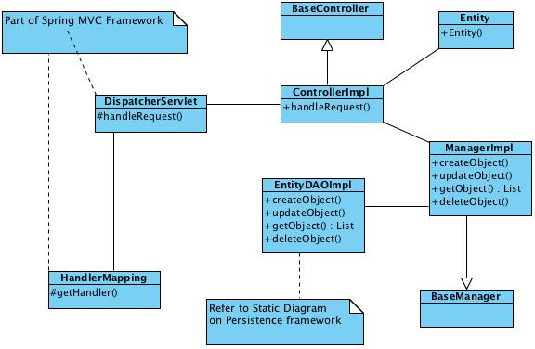

Figure 8 – Static Structure

Dynamic Interactions
The following sets of dynamic interactions are supported for each accessor function of creation, retrieval, update and deletion.

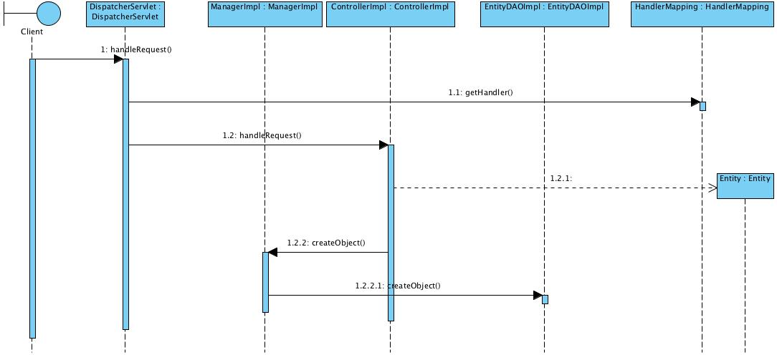

Figure 9 – Creation
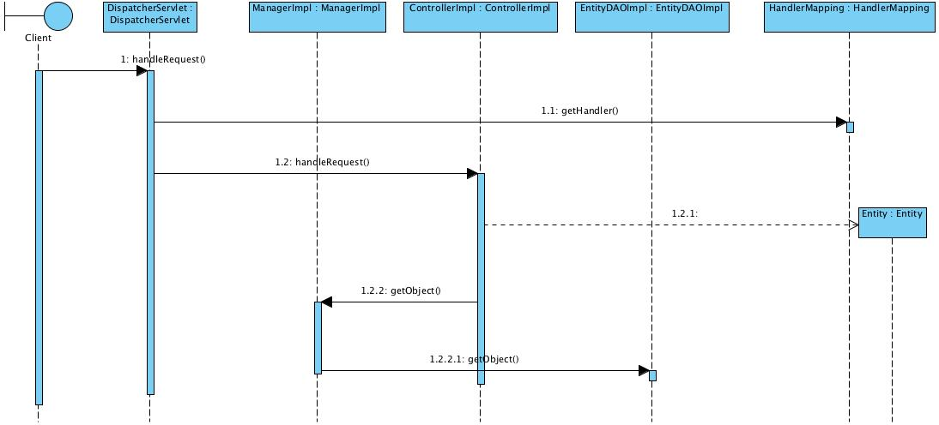

Figure 10 – Retrieval

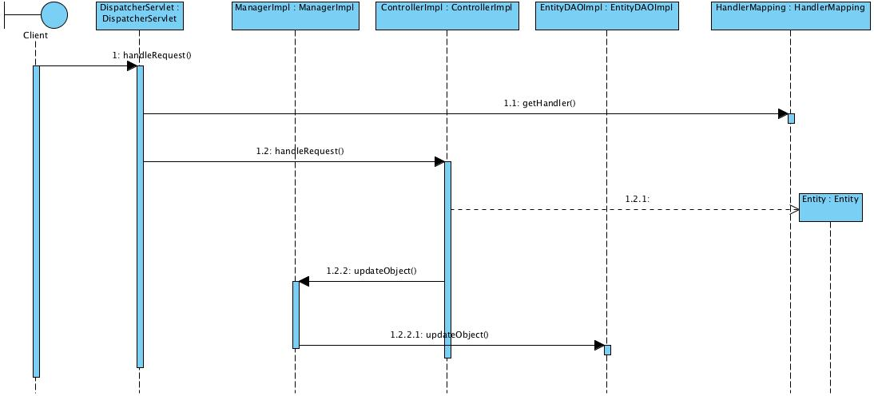

Figure 11 – Update

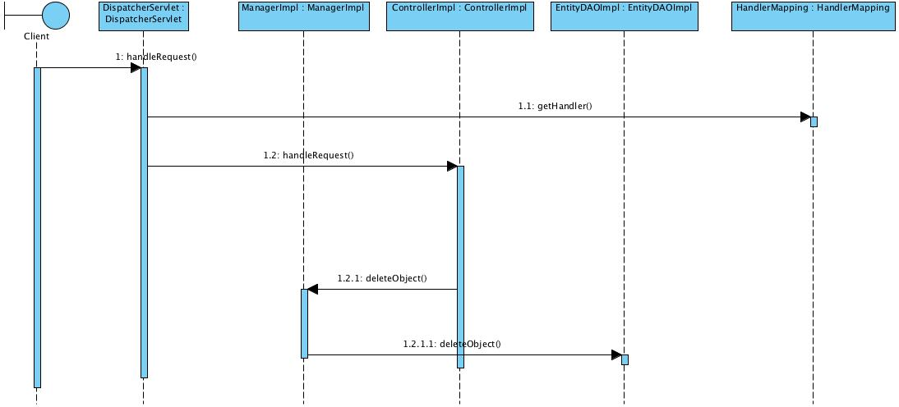

Figure 12 – Deletion

Configuration
This section contains the Spring configuration to be used.
- spring-controller-vms.xml to configure all the business logic beans/ page beans and dwr beans
- spring-hibernate-vms.xml to configure hibernate session factory
- spring-security.xml to configure the spring security interceptor

Persistence
The persistence for the VMS system is built based on Hibernate. Hibernate enables Application to access data from any database in a platform-independent manner. There is no need for the Application to depend on the low-level JDBC details like managing connection, dealing with statements and result sets. All the necessary details for accessing a particular data source is easily configurable in Xml files.
One of the issue with using Hibernate is that the client Application that accesses the database using Hibernate Framework has to depend on the Hibernate APIs like Configuration, SessionFactory and Session. These objects will continue to get scattered across the code throughout the Application. Moreover, the Application code has to manually maintain and manage these objects. In the case of Spring, the business objects can be highly configurable with the help of IOC Container. In simple words, the state of an object can be externalized from the Application code. It means that now it is possible to use the Hibernate objects as Spring Beans and they can enjoy all the facilities that Spring provides.
The details of DAO method design would be left to the programmer/designer.

Static Structure
The following class diagram illustrates the static structure of the design.
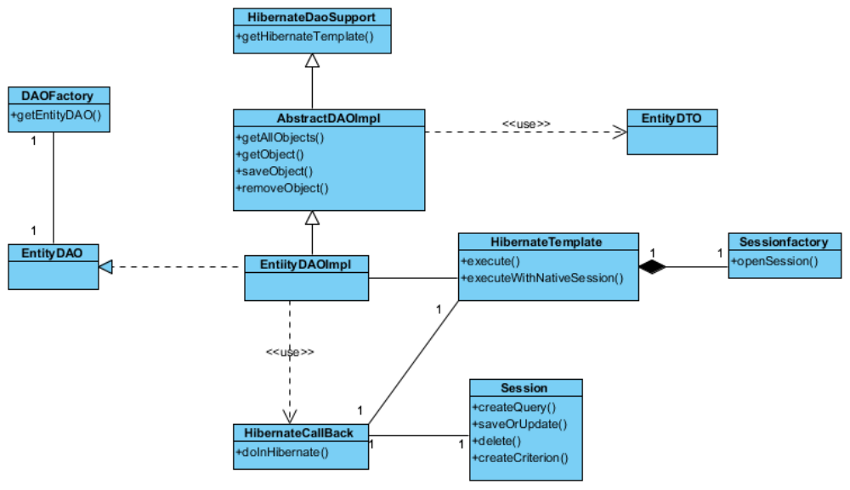

Figure 13 – Static Structure

Dynamic Interactions
The following sets of dynamic interactions are supported for each persistent entity object.
- Instantiation of a DAO
- Traversal of all the DTOs (including retrieval of the values of the attributes of the DTOs)
- Addition and Modification of a DTO
- Removal of a DTO
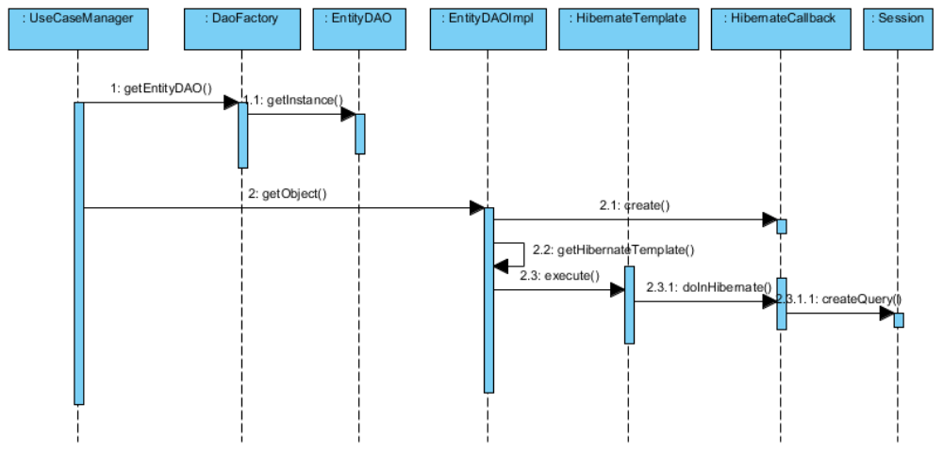

Figure 14 – Instantiation of DAO
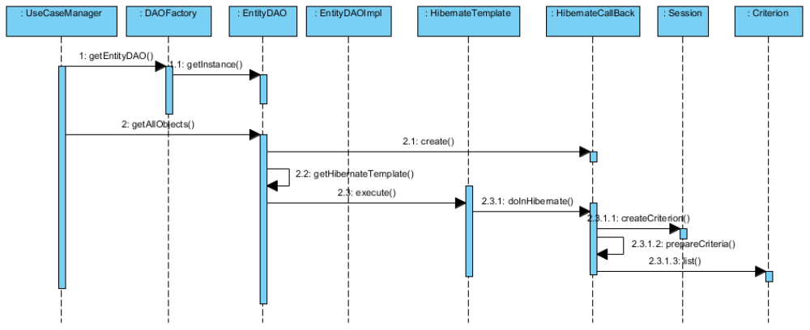

Figure 15 – Instantiation of DAO

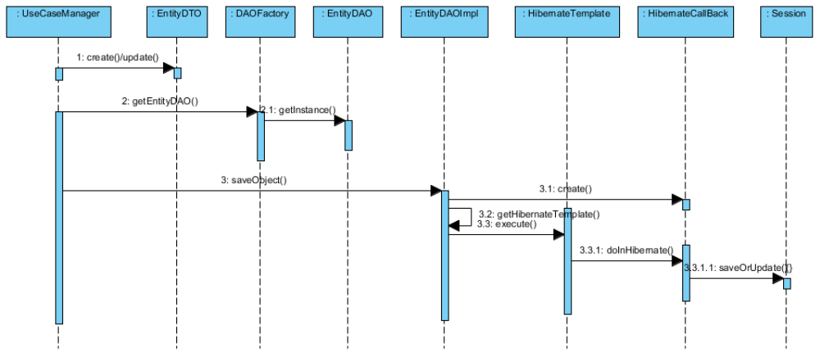

Figure 16 – Addition/Modification of DTO

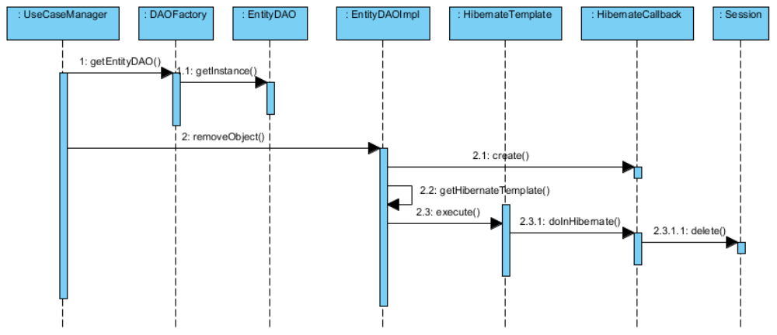

Figure 17 – Deletion of DTO

Configuration
This section deals with configuring the various information needed for the Spring Framework. In Spring, all the business objects are configured in Xml file as Spring Beans. These Spring Beans are maintained by the IOC which is given to the Client Application upon request. The hibernate-Spring bean mapping is defined as follows:
<beans>
<!-- Hibernate SessionFactory -->
<bean id="sessionFactory class="org.springframework.orm.hibernate3.annotation.AnnotationSessionFactoryBean">
<property name="dataSource" ref="dataSource" />
<property name="packagesToScan">
<list>
<value>sg.edu.nus.iss.vms.staffmgmt.dto</value>
</list>
</property>
<property name="hibernateProperties">
<props>
<prop key="hibernate.dialect">org.hibernate.dialect.MySQLDialect</prop>
<prop key="show_sql">true</prop>
</props>
</property>
</bean>

<bean id="hibernateTemplate" class="org.springframework.orm.hibernate3.HibernateTemplate">
<property name="sessionFactory" ref="sessionFactory" />
</bean>
</beans>

Table 2 – Hibernate XML Configuration
Since the annotations will be used instead of hibernate mapping files, the first bean defines type 'org.springframework.orm.hibernate3.annotation.AnnotationSessionFactoryBean’. AnnotationSessionFactoryBean.
The 2rd important Spring Bean is the Hibernate Template. It provides a wrapper for low-level data accessing and manipulation. Precisely, it contains methods for inserting/deleting/updating/finding data in the database. For the Hibernate Template to get configured, the only argument is the SessionFactory object as represented in the following section.

Standards
One module will contain one DAO object, unless it is a complex or many functions are residing within one module, and then multiple DAO objects will be created. The complexity level of a module will be left to the designer to decide.

Reporting Utility
JasperReport will be used for generation of the reports that are to be used by the system. All the template reports will be stored in the folder report within the J2EE packaging. A report utility has been designed to standard the generation of report through the use of this utility. This report utility will facilitate the retrieval of data source if needed and transformation of the report to the appropriate required format. The format that is supported by the utility consists of PDF, RTF and HTML.

Static Structure
The following class diagram illustrates the static structure of the design.
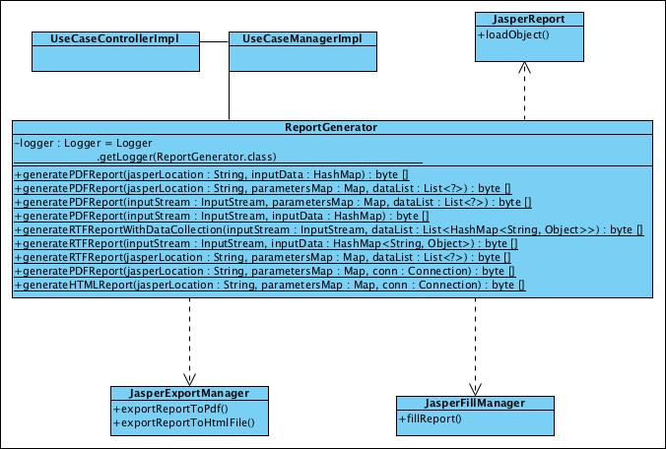

Figure 18 – Report Utility Static Structure

Dynamic Interactions
The following is the dynamic interactions supported for generation of a report using jasper.
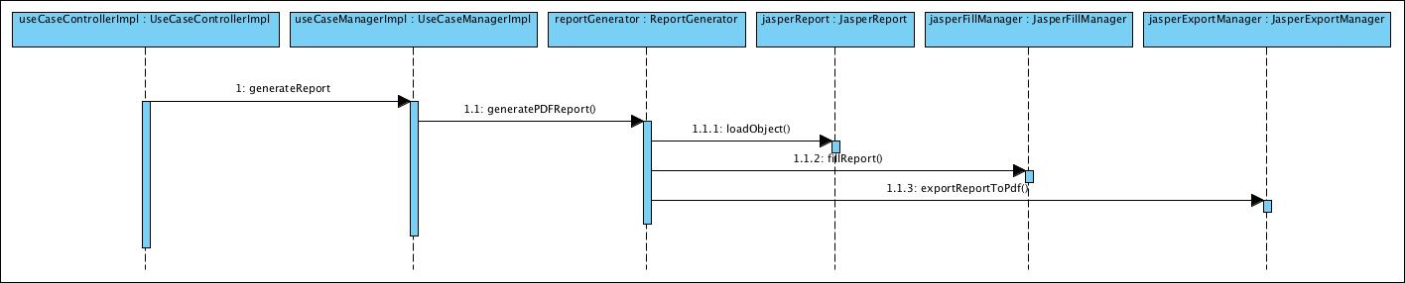

Figure 19 – Report Utility Dynamic Interactions

Others

Build Configuration
Will be using Ant 1.6.5 to compile, packaging and deploy. Ant will be used for all the deployment environments from development to production.

Other Configurations
This section discuss about all other configurations used for the system.

Configuration
Email configuration file (cfg-mail.properties) is to set email user that vms will be use to send email alert as follow.

sys.server.mail.send.host=vms.com.sg
sys.server.mail.send.username=volunteers
sys.server.mail.send.password=user123
sys.server.mail.send.port=25

sys.server.mail.receive.host=vms.com.sg
sys.server.mail.receive.username= volunteers
sys.server.mail.receive.password=user123
sys.server.mail.receive.port=110

Database Configuration
cfg-database.properties is to configure the database connection parameters such as JNDI, number of cached statements, timeout of pool connection and validation SQL. The logger will save the information into the file and file will be splitted into different file based on the file format
(“vms .log.2011-03-25.log”).

Logger Configuration
log4j.properties file can be found under the src folder. The application log flag, log level and log location configuration can be configured.
# Direct log messages to stdout
log4j.appender.stdout=org.apache.log4j.ConsoleAppender
log4j.appender.stdout.Target=System.out
log4j.appender.stdout.layout=org.apache.log4j.PatternLayout
log4j.appender.stdout.layout.ConversionPattern=[VMS] %d [%-5p] [%t] %c.%M(%-L) | %m%n

# Root logger option
#log4j.rootLogger=INFO, stdout
log4j.logger.org.springframework=ERROR
#log4j.rootCategory=error, stdout, R
log4j.rootCategory=DEBUG, stdout, R
log4j.appender.R=org.apache.log4j.RollingFileAppender
log4j.appender.R.File=logs/vms.log
log4j.appender.R.MaxFileSize=10000KB

#detail log filter
log4j.logger.mtech.se1008s.service.DispatcherServlet=ERROR

Java Naming Convention
This section defines the naming conventions that will be used for the design and implementation.

Package
All packages shall be prefixed with: sg.edu.nus.iss.vms. Further subdivision is up to the individual programmer. In the case of common code, reusable components shall be placed within a package named according to the component, such as sg.edu.nus.iss.vms.common.

Class and Interface
- Class names shall be nouns, not verbs. Eg. Staff, Project
- Interface names shall be an adjective (wherever possible) describing the enforced behaviours of the class. Preferably, interface names end in "able" following an emerging preference in Java. i.e. Clonable, Versionable, Taggable, etc.
- Class, and interface names shall begin with an uppercase letter, and shall not be pluralized unless it is a collection class.

Method
Method names are typically verbs. However they can also include nouns for example accessor methods (getter and setter). The following table describes the naming convention for method.
Accessor Type | Naming Convention | Example
Create | createXXX | createProject
Retrieve | getXXX | getProject
Update | updateXXX | updateProject
Delete | deleteXXX | deleteProject

Table 3 – Method
If the method is an accessor method, use a noun appropriate to the information that is returned, i.e.
public Project getProject()
public void setProject(Project project)

When accessing a collection class or an array, it is recommended to use pluralized noun for clarification, i.e:

public ArrayList<Event> getEventList()
public void setEventList(ArrayList<Event> )
public Project[] getProjects()
public void setProjects(Project[])

Attribute and Local Variable
Variable names shall follow the camel case convention. They shall begin with a lowercase letter. The initial letter of any subsequent words in the name is capitalized, and underscores are not used to separate words (or scope variables). Attributes that are not collections should not be pluralized. Eg. approvalName

Class & UI Naming Convention
Class Type | Naming Convention | Example
Boundary – Page | createXXX | createProject  createEvent
 | viewXXX | viewProjectList  viewCalendar
 | updateXXX | updateProject
 | deleteXXX | deleteProject
Boundary – Elements | xxxButton | createButton  deleteButton
 | xxxLabel | xxxLabel
Control | XXXController | MainController, ProjectController
Manager | XXXManager | ProjectManager
Service Implementation | XXXManagerImpl | ProjectManagerImpl
Data Access | XXXDAO | ProjectDAO
Entity | XXX | Project, Staff
Constants | XXX_YYYY | MINIMUM_WAGE
Message Property | XX.XX.XX | Message.SearchStaff.name.Label
Table 4 – Class & UI Naming Convention Method

Documentation
The implementation code shall contain detailed documentation for classes, methods, and variables, written in Javadoc style as required by the Java coding standards. The overall guidelines to generate Javadoc include:
- Document all classes and methods
- Internal details need not be documented
- Methods that implement an interface need not provide javadoc comments, since the javadoc comments are included in the interface and will be referenced when javadoc executes.
- Each method shall include the @exception, @param, and @return javadoc tags where appropriate. Eg.

Acceptable
/**
* Method to check if proscribed operation is allowed for this object.
* This method is needed to provided some level of security on operations.
*
* @param action must be an operation that has registered itself with the object
* @return boolean true if the operation is allowed, false otherwise.
* @exception UnknownException exception is thrown when an operation that has not
* registered with the object is passed as a parameter.
*
*/
public boolean operationIsAllowed(Operation action) throws UnknownException
{
}

Table 5 – Acceptable Javadoc Syntax

Unacceptable (no Javadoc tag)
/**
* operation check takes an operation and returns true or false
*/
public boolean operationIsAllowed(Operation action) throws UnknownException
{
}

Table 6 – Acceptable Javadoc Syntax

ANNEX D Amendment History

This is a record of all amendments made to the Document.
Version | Chapter / Section | Page No | Notes of Amendments or Changes

